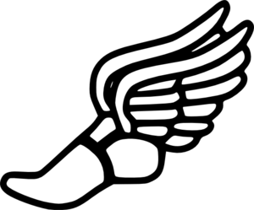
Multi-Sport Event

Who: 4th and 5th Graders
What: A clinic that will expose participants to Volleyball, Track and Field, and Bocce.
When: September 16, 2017 Check-in: 9:30am-10:00am
Event: 10:00am- 12:30pm
Where: Moyer Park: Moyer Rd, Damascus, Maryland, United States

Items participants should bring: Wear appropriate clothing for physical activity. Sunscreen, hats/sunglasses, and a water bottle are highly recommended but not required.

To RSVP: Please go to (www.SignUpGenius.com/go/508084CABA82BA1F94-multi ) to sign up for event. Spots are limited and the deadline to sign up will be 9/13/17. An email will be sent prior to the event as a reminder.

**If you do not have internet access, call 301-253-5264. Leave a message with name of participant, grade, parent/ guardian name, and phone number. You will be added to the list and I will contact you with any necessary information before the event.

REMINDER: A parent, guardian, or adult will need to be present before the event to check participant in and sign a safety waiver. All Girl Scout activity safety codes will be followed during the event.
In the event of rain, contact will be made to all participants

If there are any questions, please contact activateselfconfidence@yahoo.com
To learn more about my project, visit my website at
projectactivateyourself-confidencegsgold.weebly.com

